**Assignment 6.4**

**Problem Statement:**

Titanic Data Analysis Write a mapreduce program to find out number of males and females died in the titanic tragedy and save the output in KeyValue Output format.

**Program:**

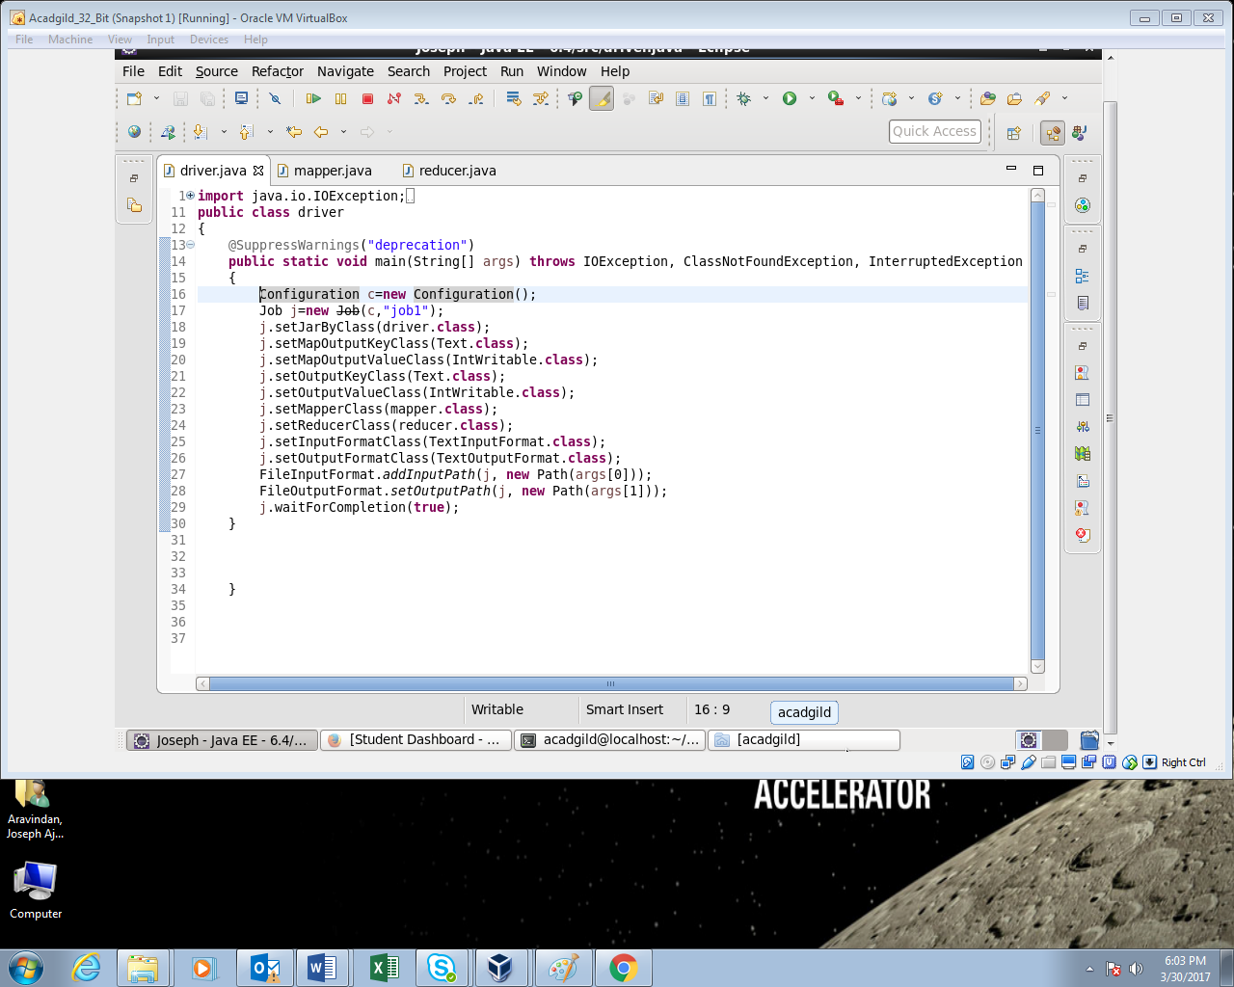

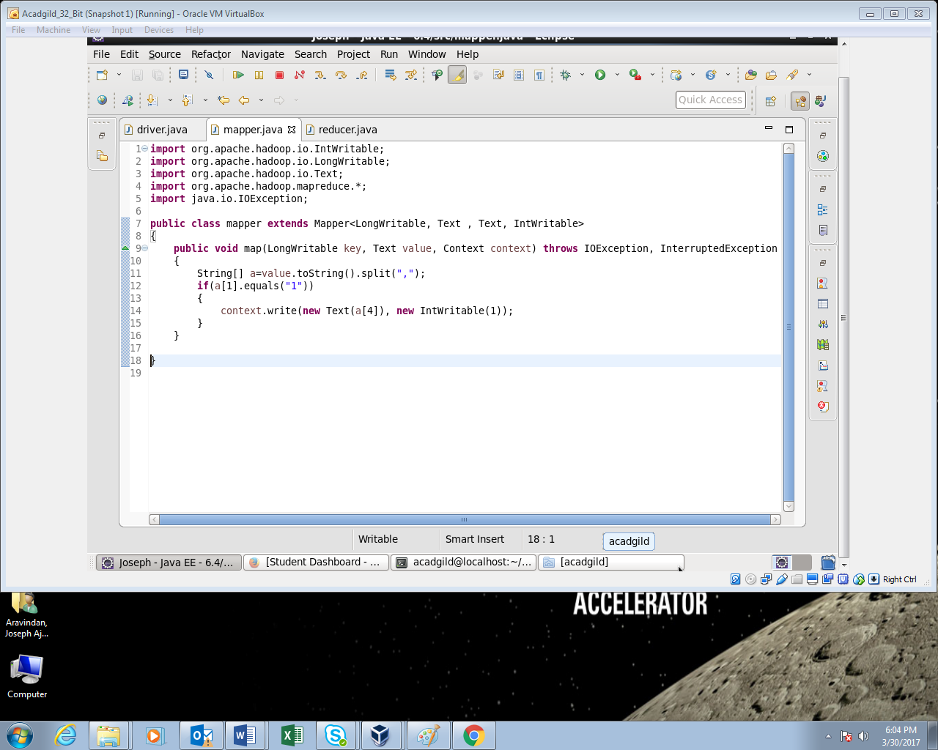

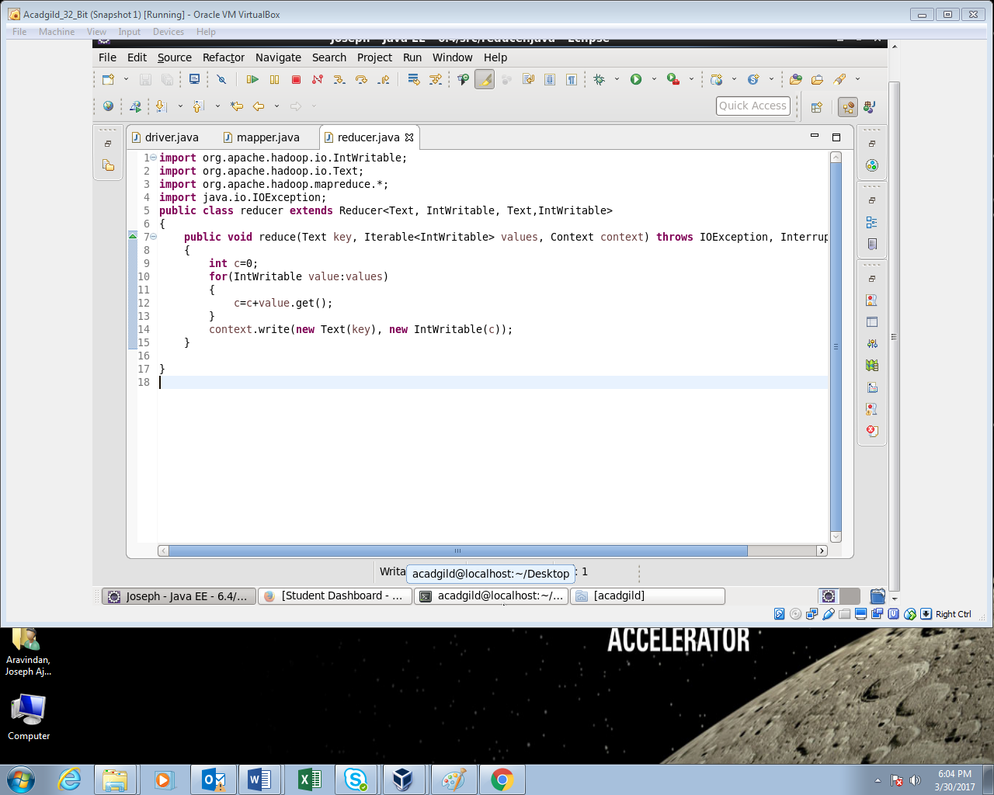

**Output:**

